December 20th, 2009
Hi
I have had a rather miserable week because of what I assume is a cold – sore throat (rhs), lots of nose mucous, though not much of a runny nose and no coughing or fever. It started last Saturday (I noticed a slightly sore throat after the run) and has still not completely gone. It is a long time since I have had a severe cold and cannot remember when that might have been. Interesting though that I can exercise my way through a cold. I still did the regular exercise in the gym though with reduced intensity. On the treadmill, instead of running, I walked at maximum walking speed. I also did the rowing a bit slower – I think. As I did not want to know how slow I might have been rowing, I covered up the instrument monitor so I could not see it! From experience I had found that for me, it is impossible to exercise with the flu; it is just like hitting a wall, the body just cannot do it, and especially with running.

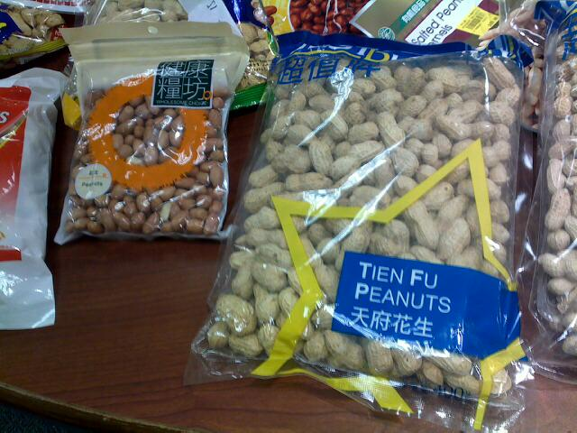
The HK Consumer Council tested 50 kinds of and peanut products and found that 23 of them had high levels of cadmium, a metal that causes kidney damage. Most of them are from China of course. That is bad news for me as I buy three packets of salted peanuts each time I go to the supermarket. I consume less than the suggested daily limit and the manager of the supermarket said this brand is all right – let’s hope so!

Yesterday I had a good run. Conditions were also very good. At 2 hrs 9 min, the run was a whopping 19 min or 13% faster than last there. However, the comparison is not fair as last year, I was running with a damaged Achilles heel. On Wednesday, I go to have the biopsy on my nose. Also, starting this week, the government is giving free swine flu vaccinations for the groups of people most at risk. The CE and other senior government officials got high-profile jabs, which were shown in TV. This past week, three people in HK died of swine flu, some of them normally healthy with no underlying problems.


Saw the first test flight of the new 787, which took place the other day though about two years later than planned. Should be a good aircraft once it is in service. Also saw a TV news item of Marines from Camp Lejeune departing for Afghanistan. The climate change conference ended in disappointment with no real agreement. I could not help believing the comment made by Chavez (president of Venezuela) that for capitalists, if the climate were a big bank, the problem would have been solved by now. He makes many ridiculous comments but this one was quite good.


Nadine, I remember you saying how you like Sydney because there are always many community activities being held. Well last night they held their “Carols in the Domain” I watched it live on the Australian TV channel. It was good, except that the station kept having breaks whenever there was spectator participation and only showed the ‘show-biz’ parts. Have you heard of the ‘Wiggles’? They were there. There were also visitors from overseas including Engelbert Humperdinck – you have probably not heard of him. More for my age, though I prefer the singing of Tom Jones to his. In HK, we have been hearing about the ‘Nutcracker’, which will be performed again as usual at Christmas time.
Did you see on TV, the poster (below left) that was on display outside a church in Auckland? I saw it on several international TV stations. It was supposed to generate discussion about the Christmas story. It did indeed, though probably not what was intended. Within five hours, the posted had been defaced (below right). Read the caption. Do you get it? [Man = Joseph = the (earthly) ‘father’ of Jesus. Woman = Mary = Jesus’ mother. Jesus was (supposedly) conceived by divine measures/God. His younger siblings were conceived naturally.]


I have just heard on the local radio news that a blizzard is heading up the Northeast and towards Boston, the worst for decades. My e-mail opening page has a ‘weather’ icon with temperatures for cities with Boston as the default city. You are certainly getting very cold temperatures at the moment. Too cold for me.
That’s about it for now.

Cheers

